Erika Bailon
Nimra Sharnez

Nimra’s procedure:

- Making clothes
- Sketch a drawing
  - Decide the design will be for a female
  - Decide we are making a sweater
  - Draw the silhouette of the female
  - Draw the design of the sweater on the female
  - Pick the colors and material and quantity
- Get fabric
  - Go to store with the sketch
  - Buy thread fabric with the matching color and material
  - Purchased the material
- Sketch out design on fabric
  - Use original sketch to draw with chalk the design on the fabric
    - The fabric is flipped to the inside of the design
  - Put needles around the chalk outline
  - Cut the extra material
- Set up the sewing machine
  - Plug in the machine
  - Set the bobbin on the machine
  - Put desired thread on bobbin
  - Put the bobbin in the bobbin case and shuttle race
  - Turn on the light of the machine
  - Set up the thread through the needle clam and screw
- Sewing the fabric
  - Put the beginning of the chalk sketch on the throat plate
  - Set down clamp and needle
  - Sew using the pedal
    - Remove needles as needed
  - Turn off the machine
- Final touches
  - Cut extra material after sewing
  - Flip sweater back to right side out
- Try on the design
  - Try one the sweater in front of a mirror to see if it looks good
    - Fix the sewing if needed

Personas:
The first persona that would use a clicker is the following
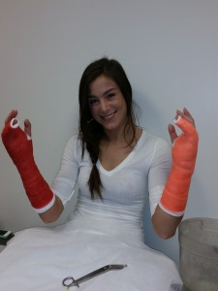
Her name is Blanca Nalgepa
Blanca is a 20 year old Caucasian girl, 5’5” and about 140lb. She is an athlete student in the University of Boulder who attends most of her classes to complete her Political Science Major. Blanca is a really good student. She tries to always be at the top of her classes. Last week Blanca had an accident and broke both of her hands. She is going back to school this week with both of her hands broken. Some of her classes require the use of a clicker to take attendance and to participate during the class.

Frustrations
Blanca has always participated in all the class activities and all the clickable questions that are displayed in the projector during class. This week Blanca cannot force her hands to push the buttons on the clicker because her hands are really weak.
Goals
Blanca wants to be able to participate during class and be at the top of her classes again.
Blanca wants to be able to use the clicker without any pain caused by it.
Blanca wants to be able to promptly respond with the clicker.
Tasks
Attend classes and participate.
Complete homework and group projects.
Attend physical therapy to heal both hands.

The second persona that would use a clicker is the following
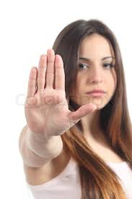

Her name is Cierra Pearson
Cierra is a 24 year old Caucasian girl, 5’6” and about 152lb. Unfortunately, she got the genes from her grandfather that passed her the Parkinson's disease at a very young age. Cierra since little was interested in Neuroscience trying to understand how the brain works and how it contributes to the body behavior. Cierra is attending CU Boulder to complete her BS/MS degree in Neuroscience and has accommodations because her hands are getting worse with time. Some of her classes require the use of a clicker to take attendance and to participate during the class.

Frustrations
Cierra has complications when she tries to click in one button on the clicker because her fingers move without her control and sometimes she wants to push one button, but her fingers move and she pushes another button.
It is hard for Cierra to promptly respond because she needs to focus on which button she needs to play without her fingers moving to another one.
Goals
Cierra wants to be able to correctly push one button without accidentally pushing something else.
Cierra wants to be able to quickly find with the fingers the button she wants to press and have no other buttons around that could change her answer.
Tasks
Attend classes and participate.

